ASSINGMENT – 02

CREATING A TABLE

DISPLAYING TABLE

INSERTING VALUES

DISPLAYING THE VALUES

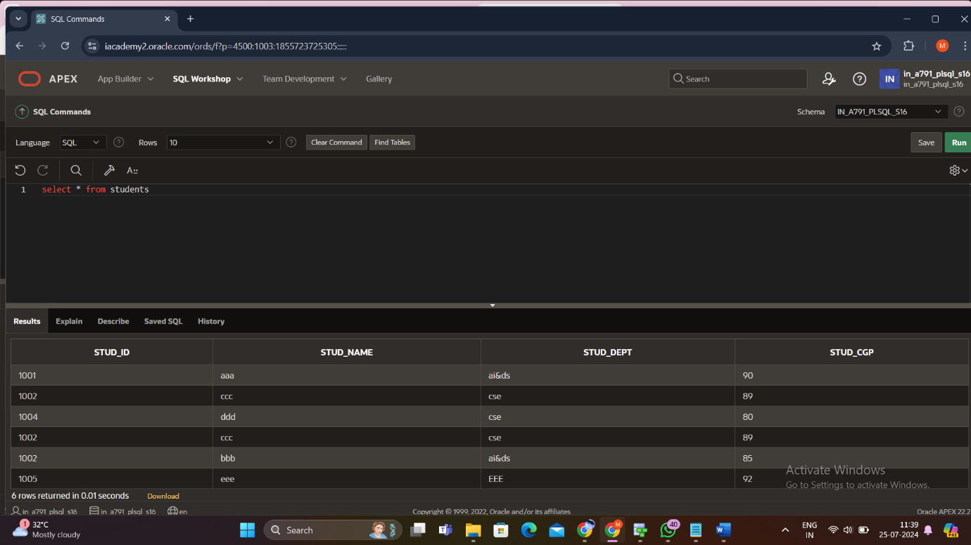

ALTER TABLE

UPDATING THA VALUES

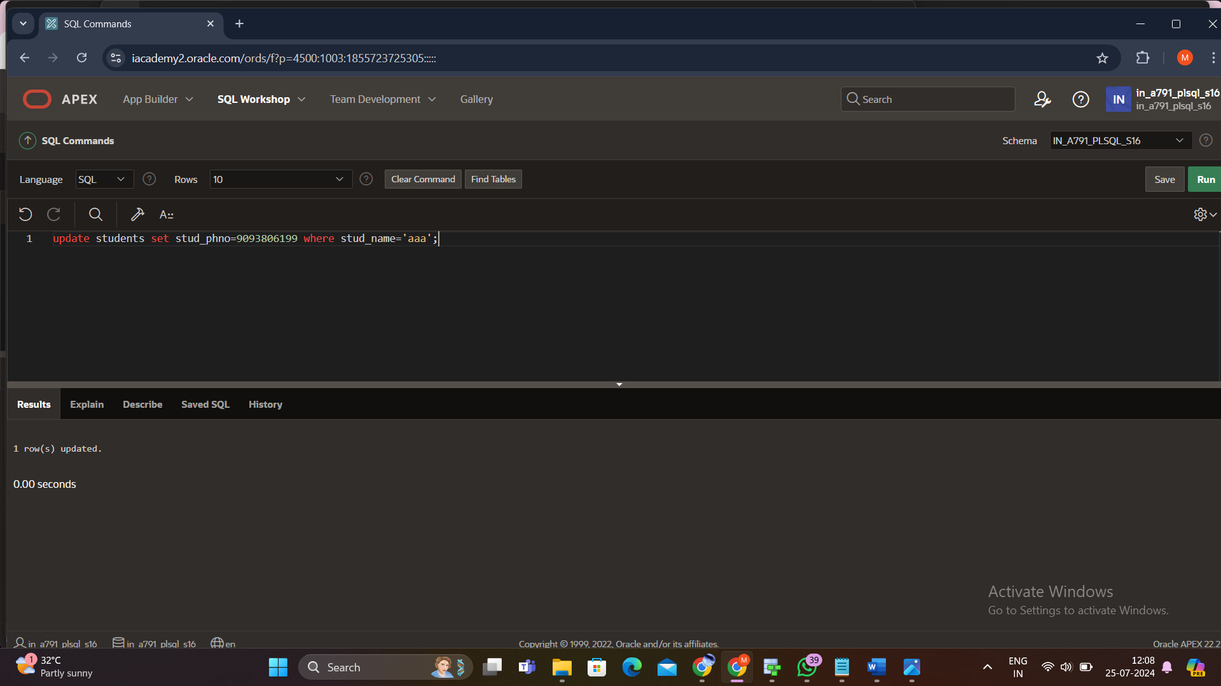

TRUNCATE TABLE

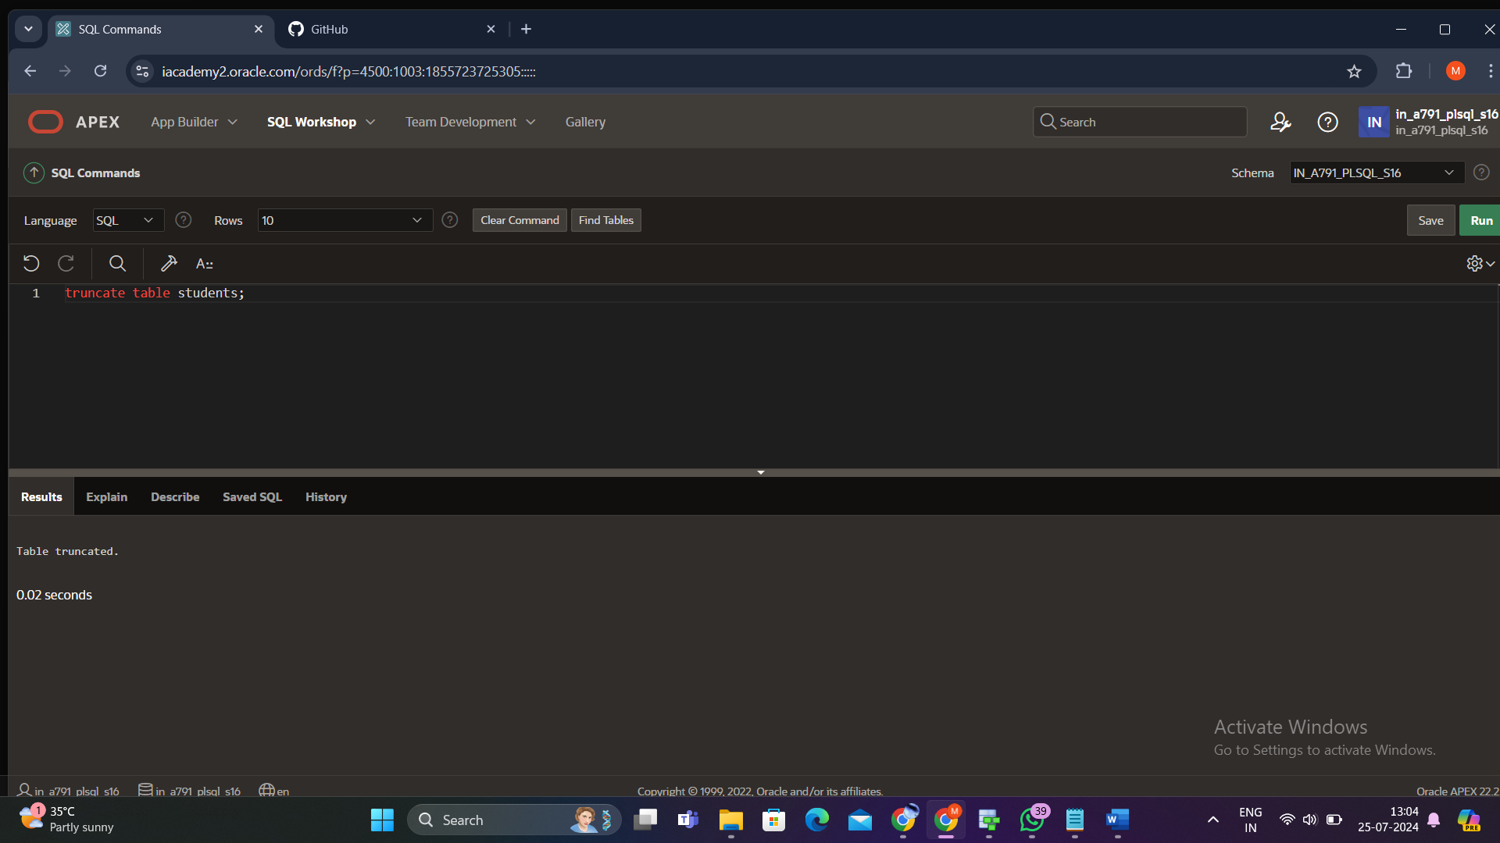

DROP TABLE

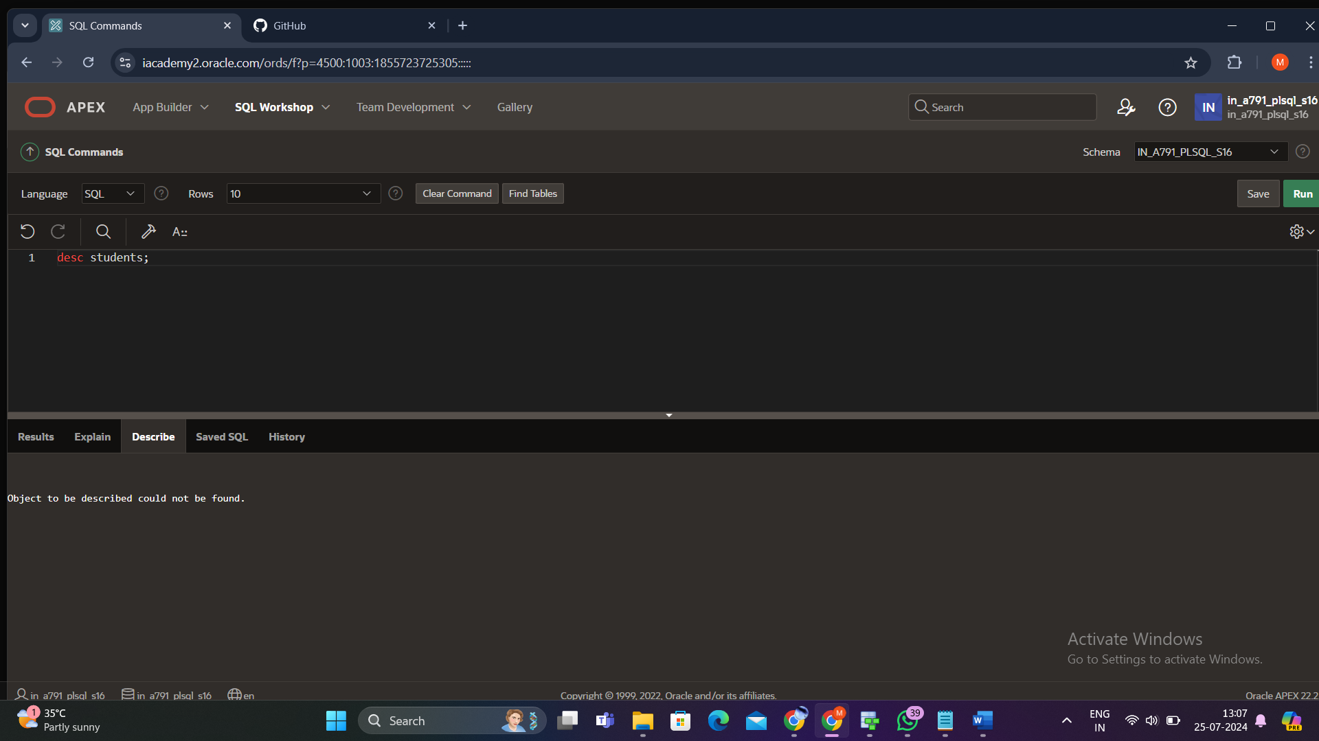

SUM

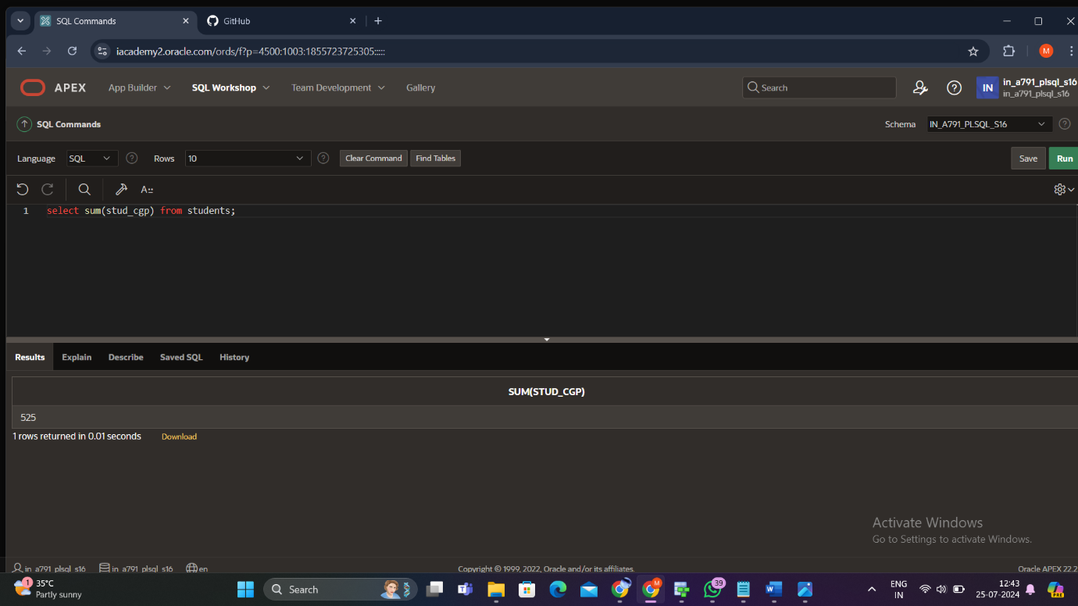

MAX

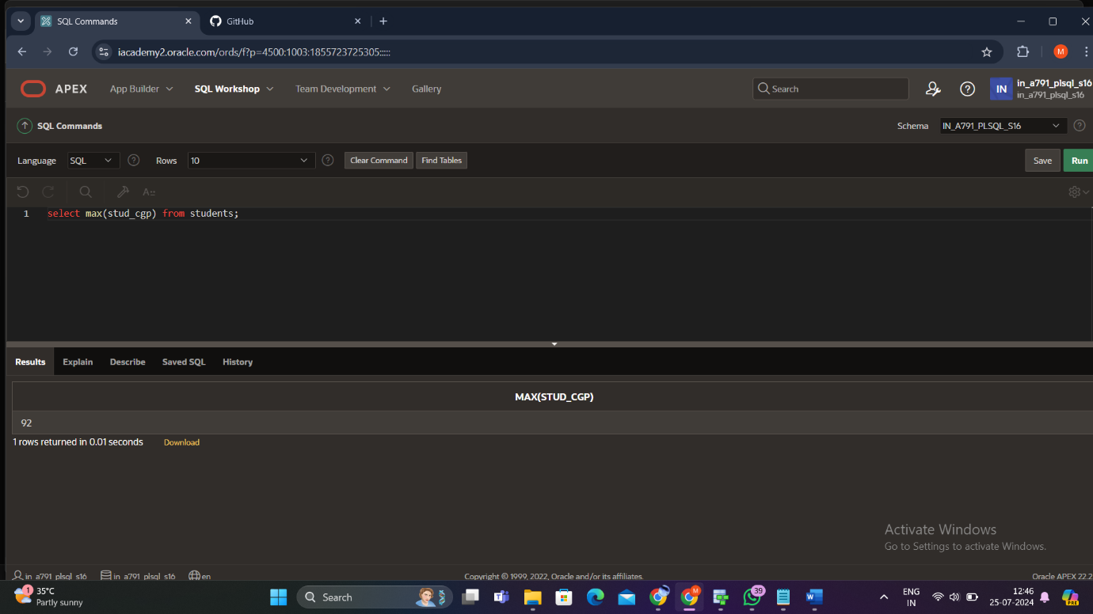

MIN

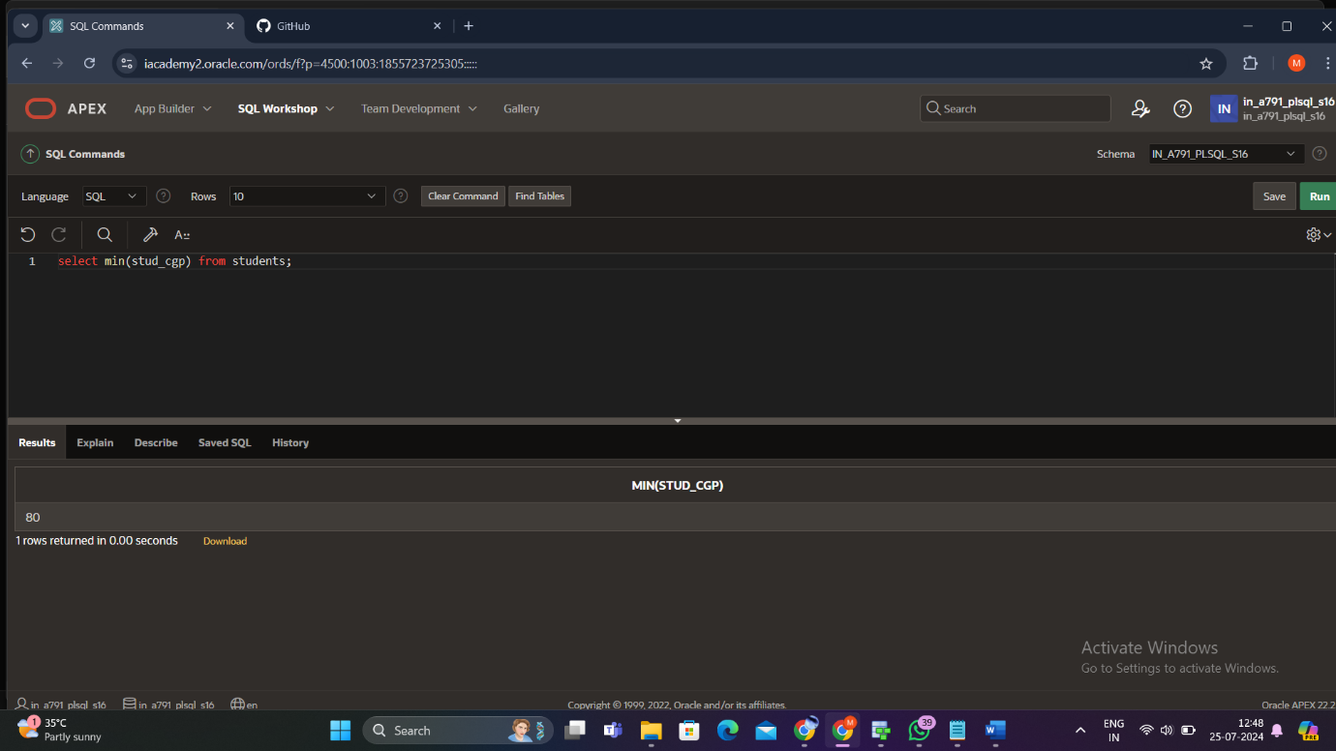

AVERAGE

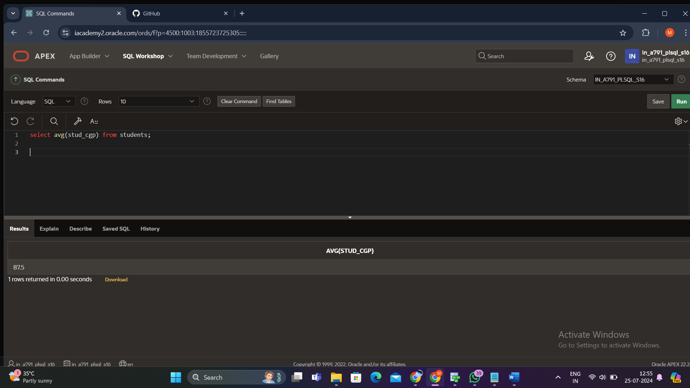

COUNT

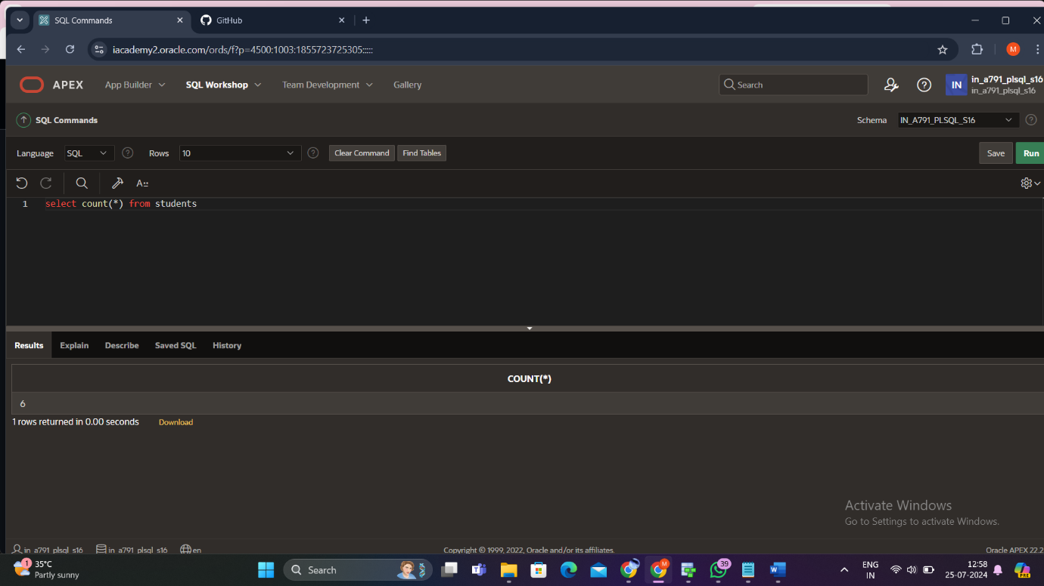

ORDER BY

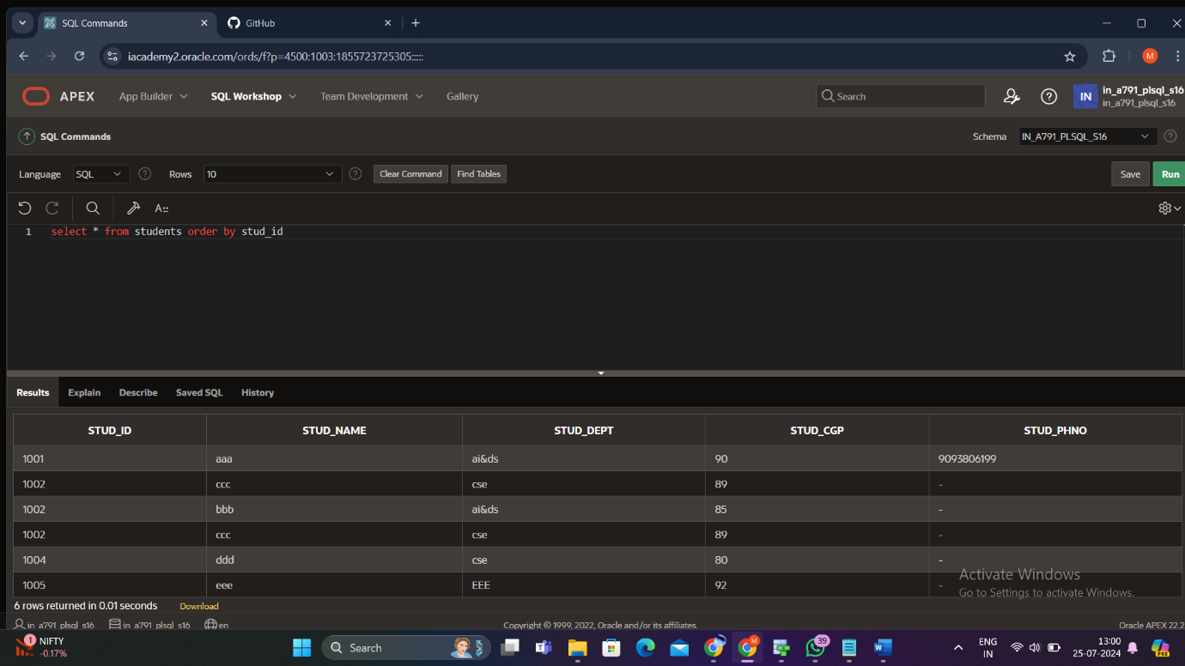

GROUP BY

